ZOOM MEETING INSTRUCTIONS

- Setting up a Zoom Meeting
Log into Zoom: https://us02web.zoom.us/signin#/login
User Name: cac.fairwayvillas@gmail.com
Password: 8Q5S4BHl9olE

- Click on ‘Meetings’ in the left column.
- Click on ‘Schedule Meeting’ to create a meeting.

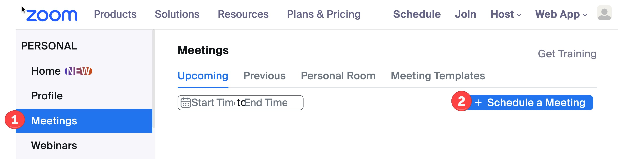

- Enter a ‘Topic’, “CAC Community Meeting”.
- Enter ‘Date & Time’ of the meeting.
- Enter ‘Duration’, typically 1 ½ hours for the CAC Community Meetings.

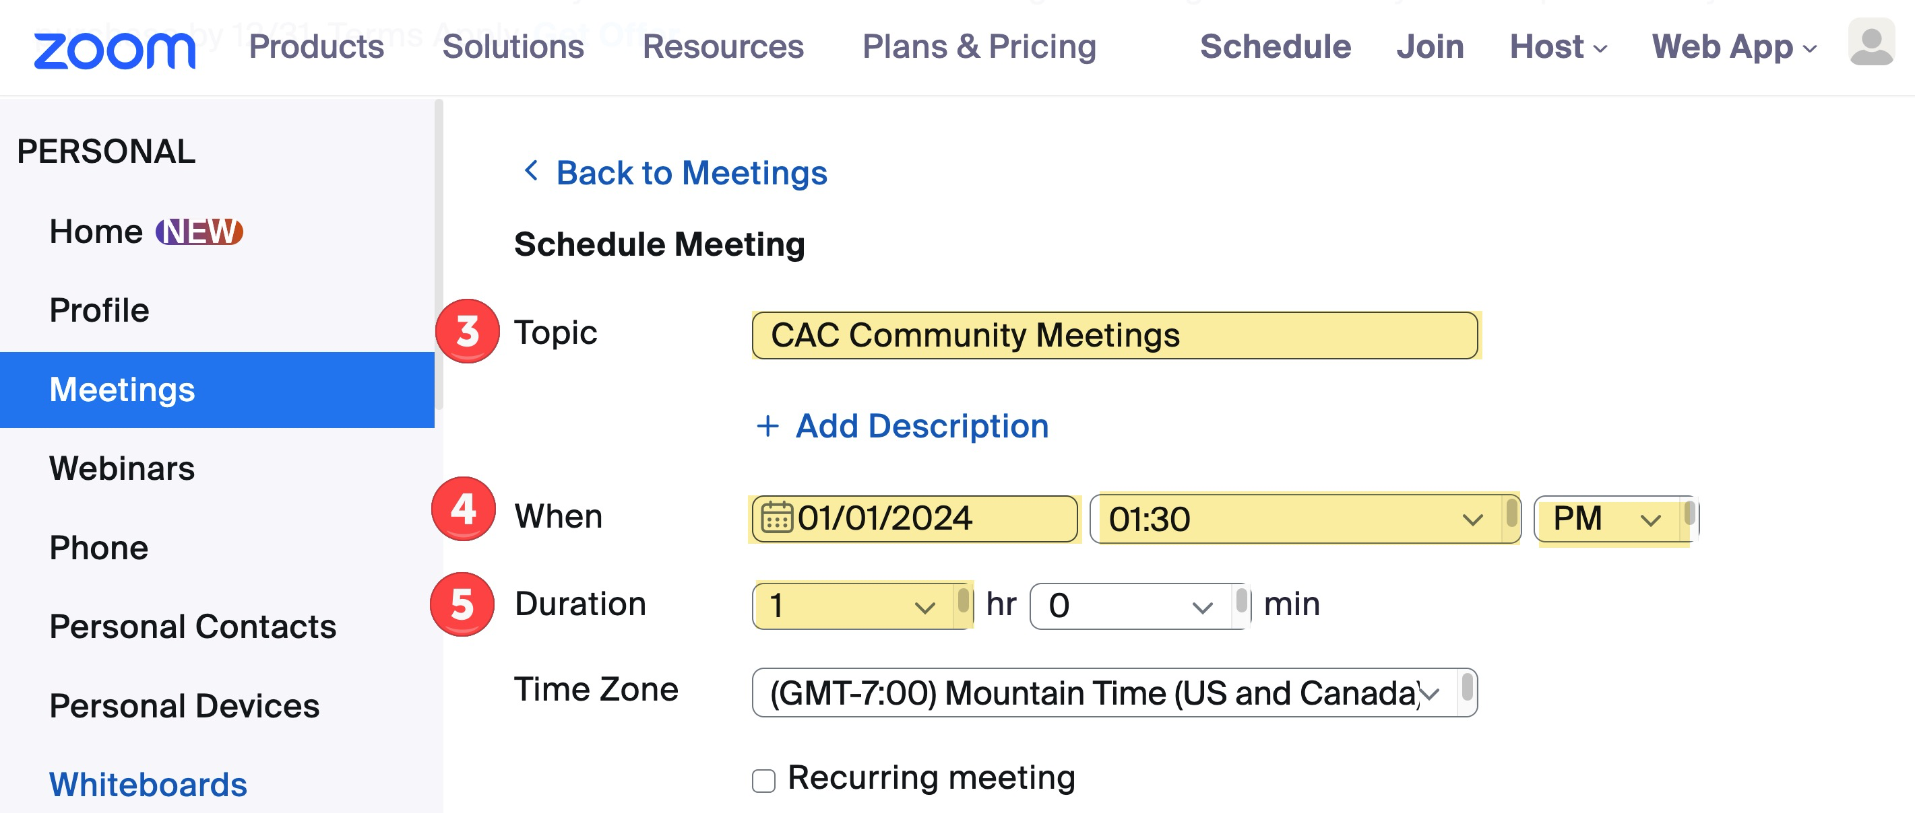

- Select a ‘Template’, “CAC Meetings.
- Click the ‘Save’ button.

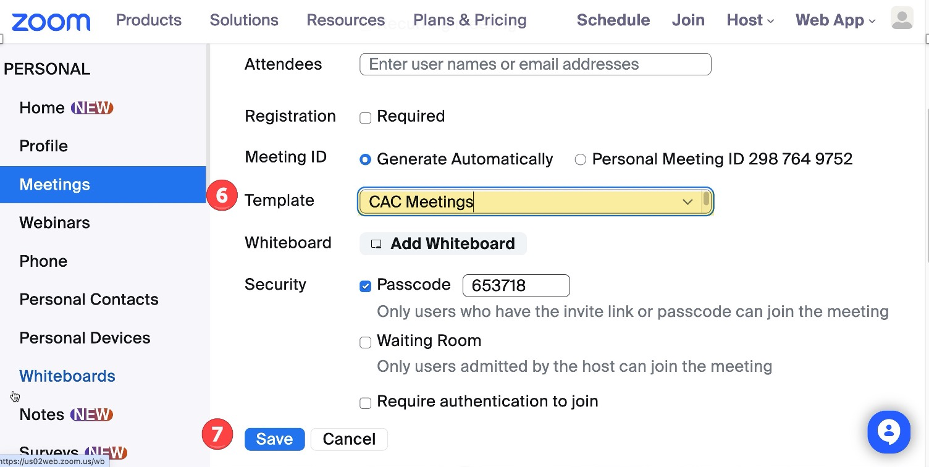

- Click on ‘Copy Invitation’.

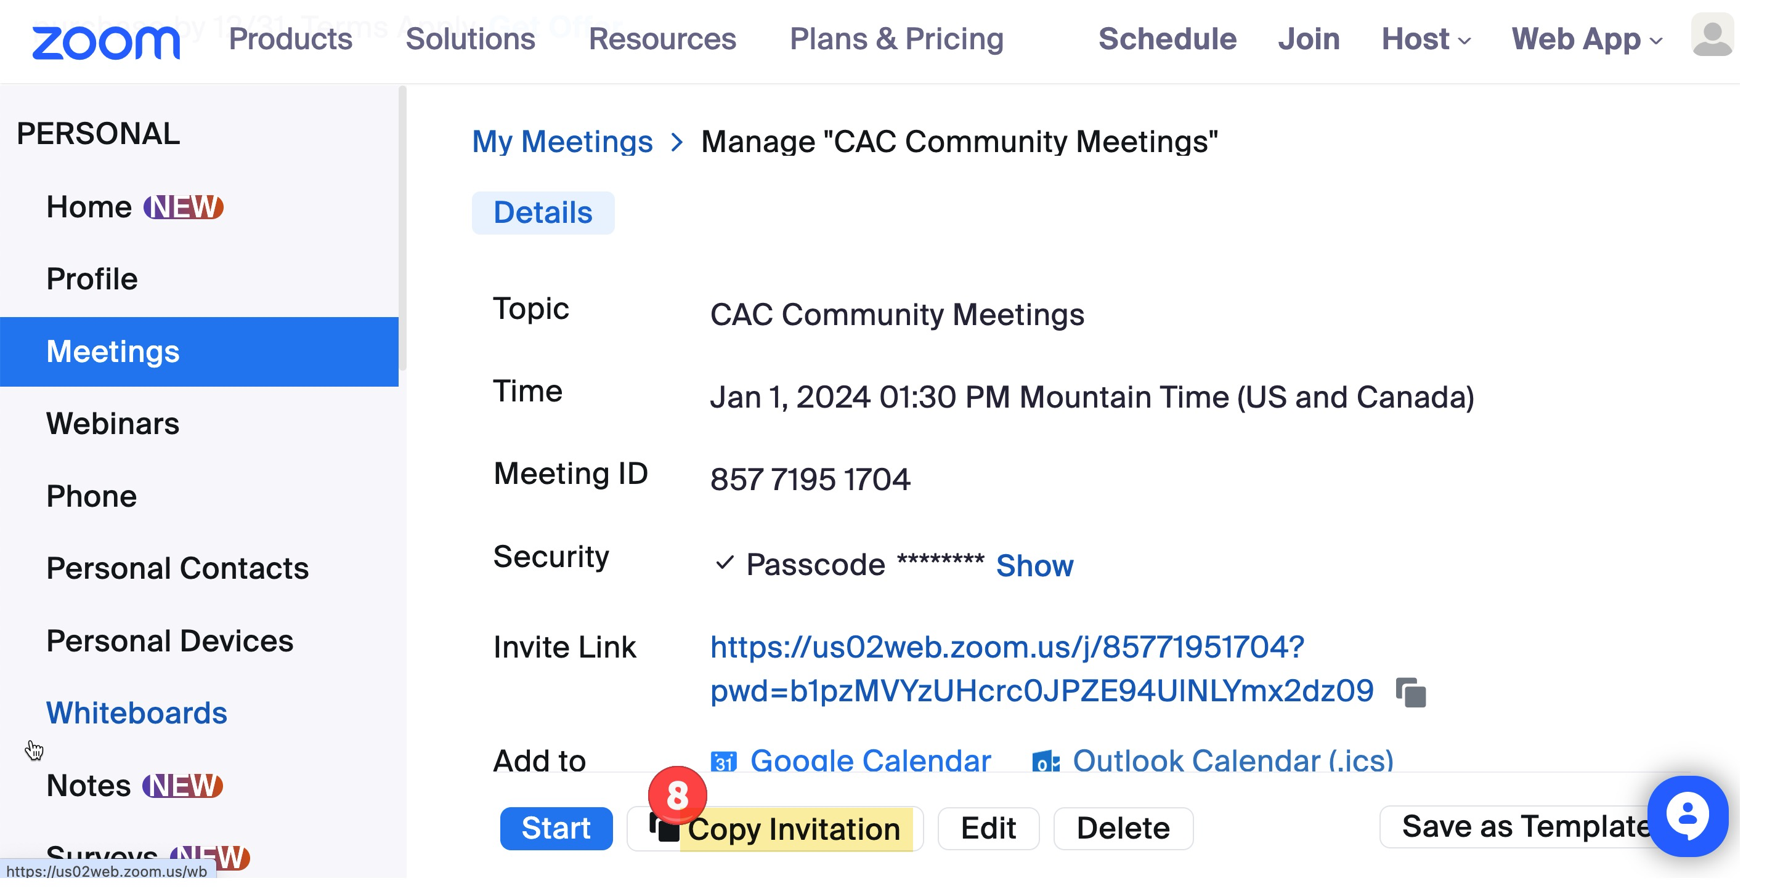

- ‘Copy Meeting Invitation’
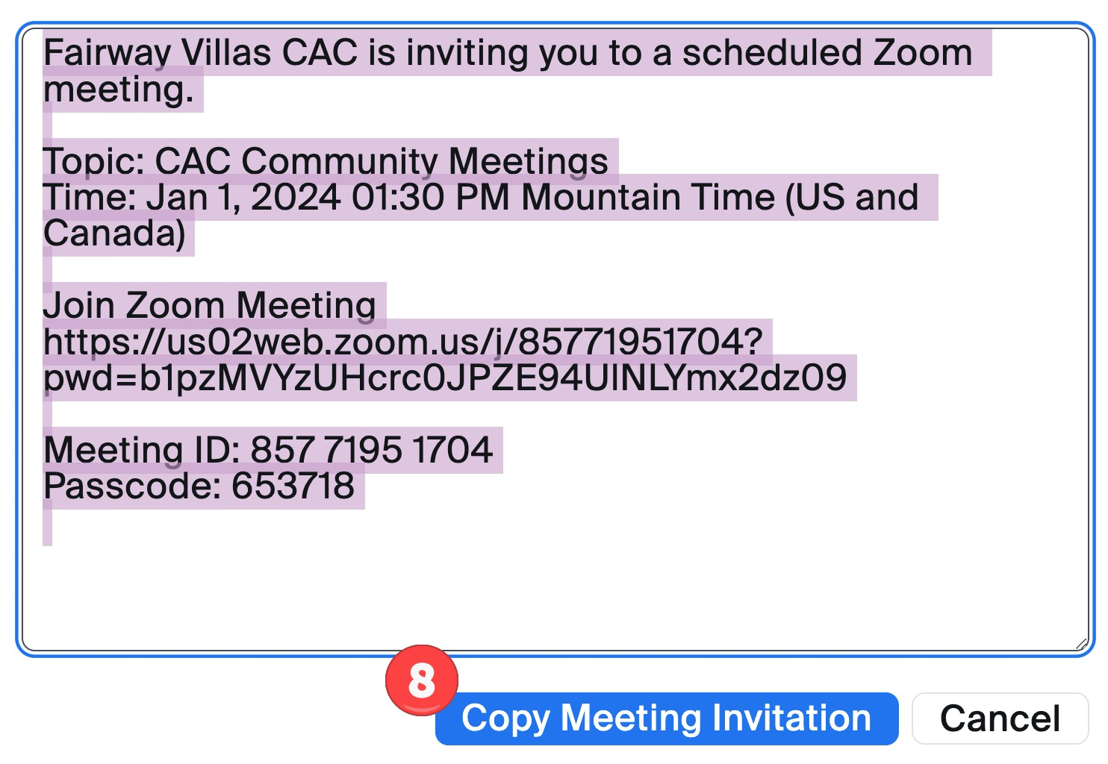

NOTE: The information you copy needs to be:
- Emailed to Gina, Lifestyle Manager to put in the Newsletter.
- Start an Email in the cac.fairwayvillas@gmail.com account.
  - Paste the copied Zoom Meeting details.
  - Modify the Invite (highlighted in yellow).
  - Highlight the link and click the “Link” icon. It will change it to a true link.
  - Attach the Agenda (typically generated by the Chair)
  - Save as a Draft by click the ‘X’ in the upper right hand corner.
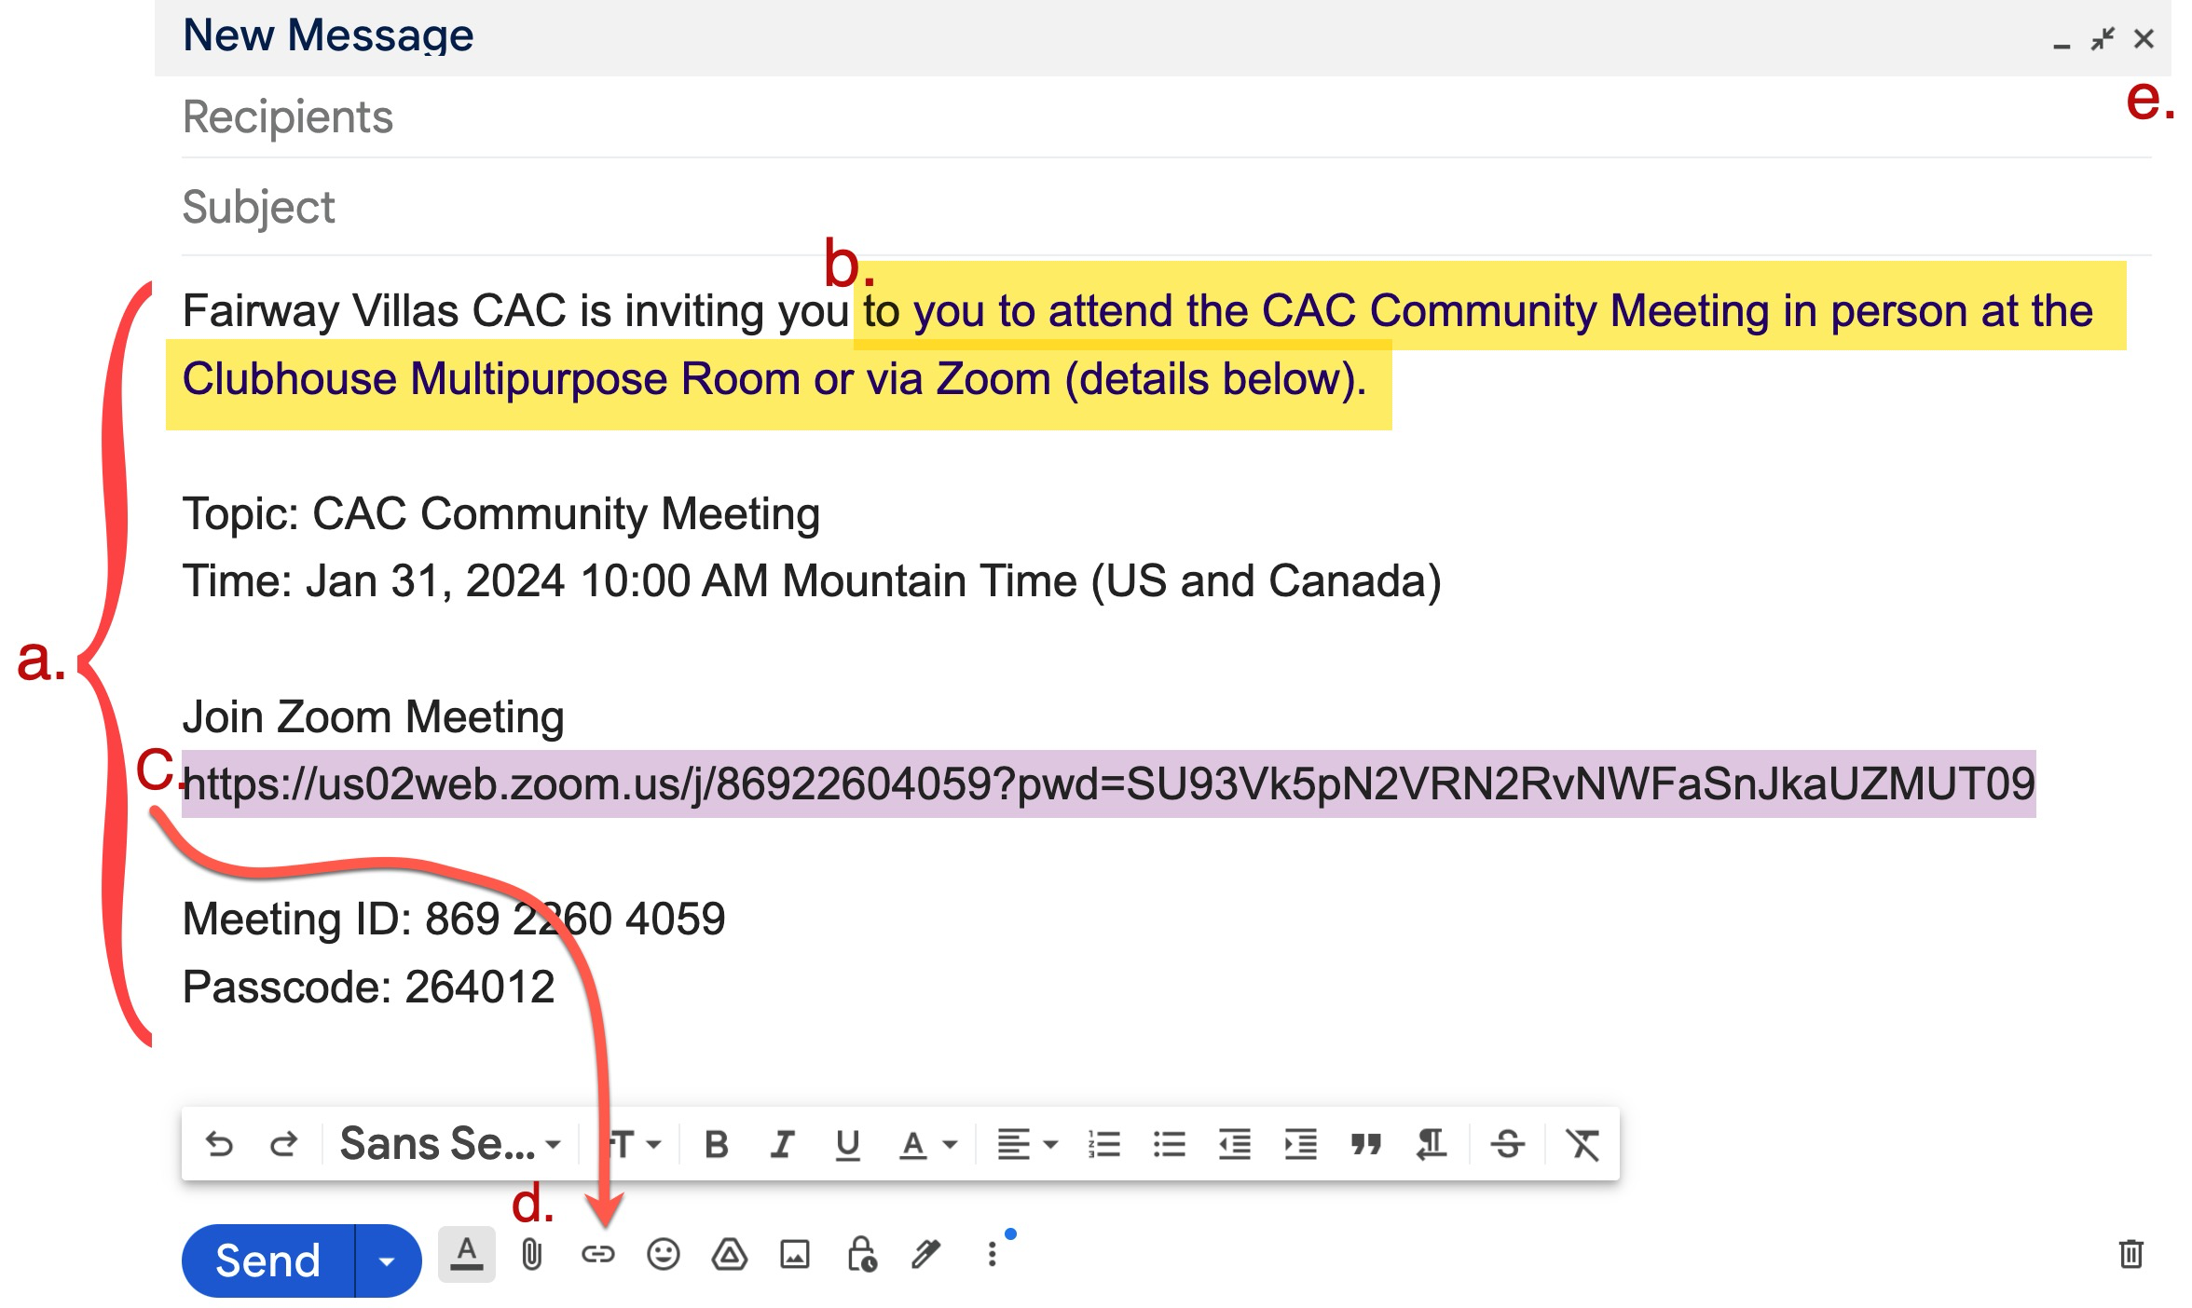

- Contact Walter to let him know the email is ready to be sent to all residents.
  - Walter will BC residents from the latest resident list and send the emai

==============================================================================

- CAC Community Meeting
Log into Zoom: https://us02web.zoom.us/signin#/login
User Name: fvcac.gvrn@gmail.com
Password: 8Q5S4BHl9olE

- Click on Meetings
- Hoover over CAC Community Meeting, then the Start Meeting button will appear.
- Click the blue ‘Start’ button.
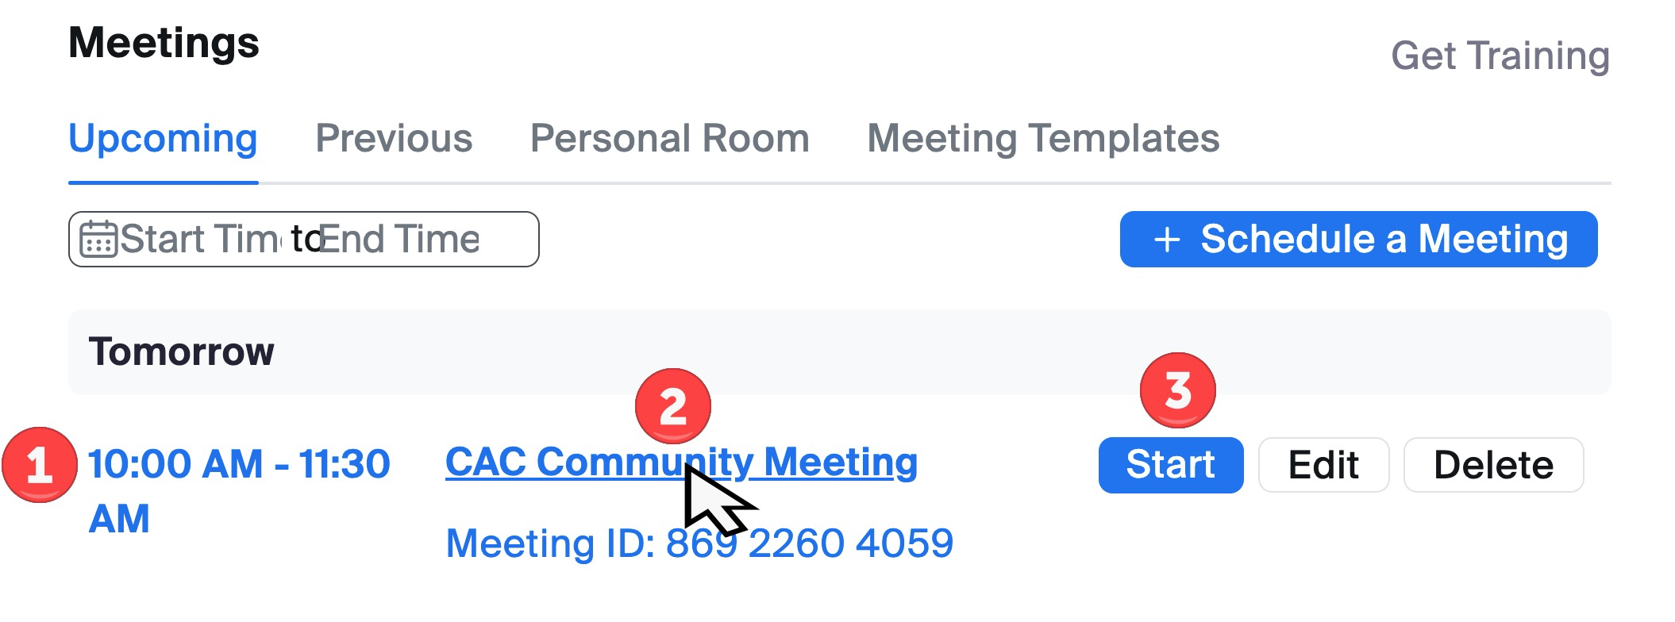

- Click the up arrow next to Mute.
- If the Owl is plugged in properly, you will see it in the list. Click on the Owl.
- Click the up arrow next to Stop Video.
- If the Owl is plugged in properly, you will see it in the list. Click on the Owl.
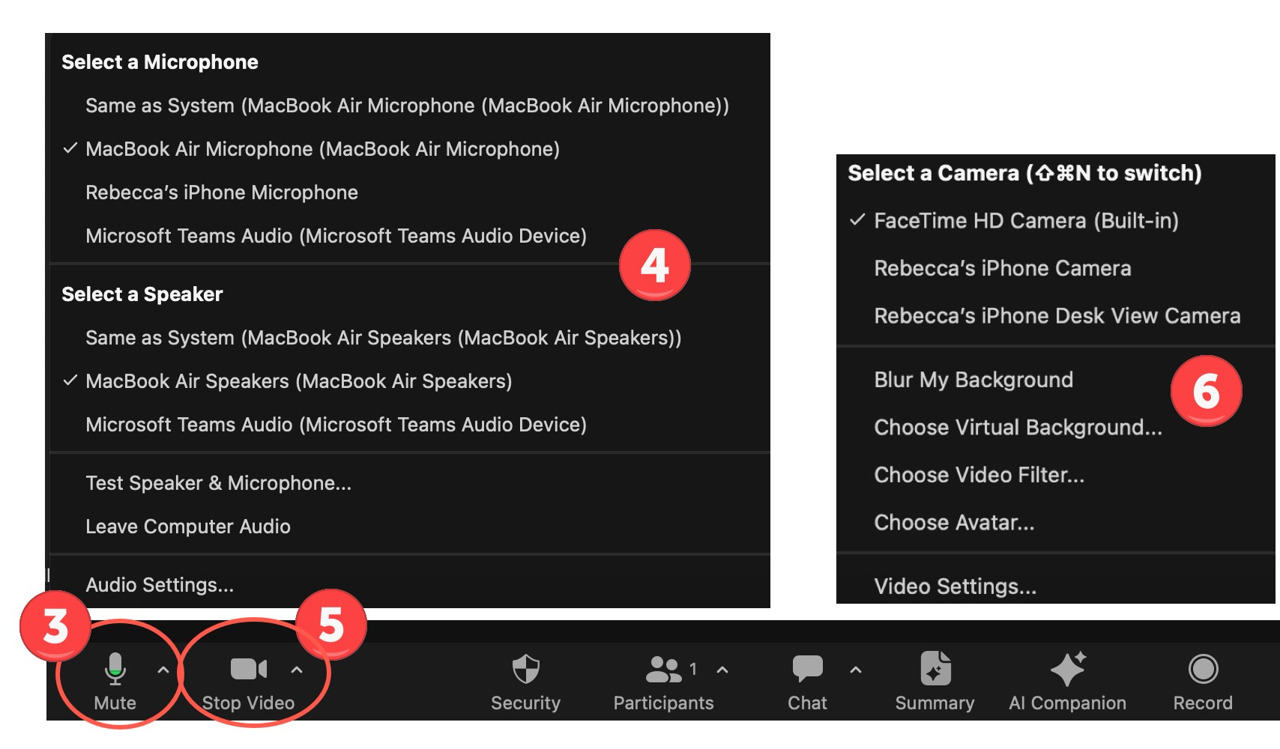

- Click the up arrow next to Participants.
- You should be able to see participants that have joined the meeting.
- Ask the participants if they can hear you.
- Click the up arrow next to Chat.
- You should be able to see any chats started by the participants.
- Click on the ‘RECORD’ button, once the meeting officially starts.
- When meeting is over, click the ‘END’ button.

- You will see the recording being saved on your laptop.
- Once completed go to the “Post Recording on YouTube” instructions.

REFERENCE: CAC TEMPLATE
