CAC Email Account INSTRUCTIONS

NOTE: If you currently have a GMAIL account you will need to set one up in your name before you can access the CAC Fairway Villas Gmail account.

- Open your Gmail account
  - Click on your account icon in the upper right hand corner.
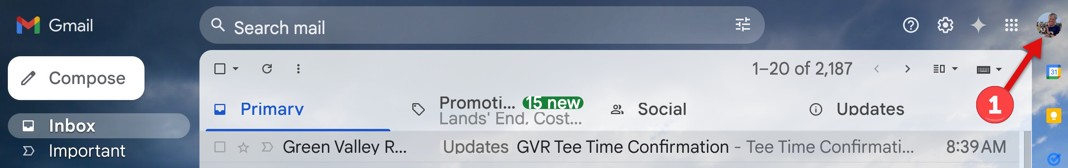

  - Click on “Add another account”
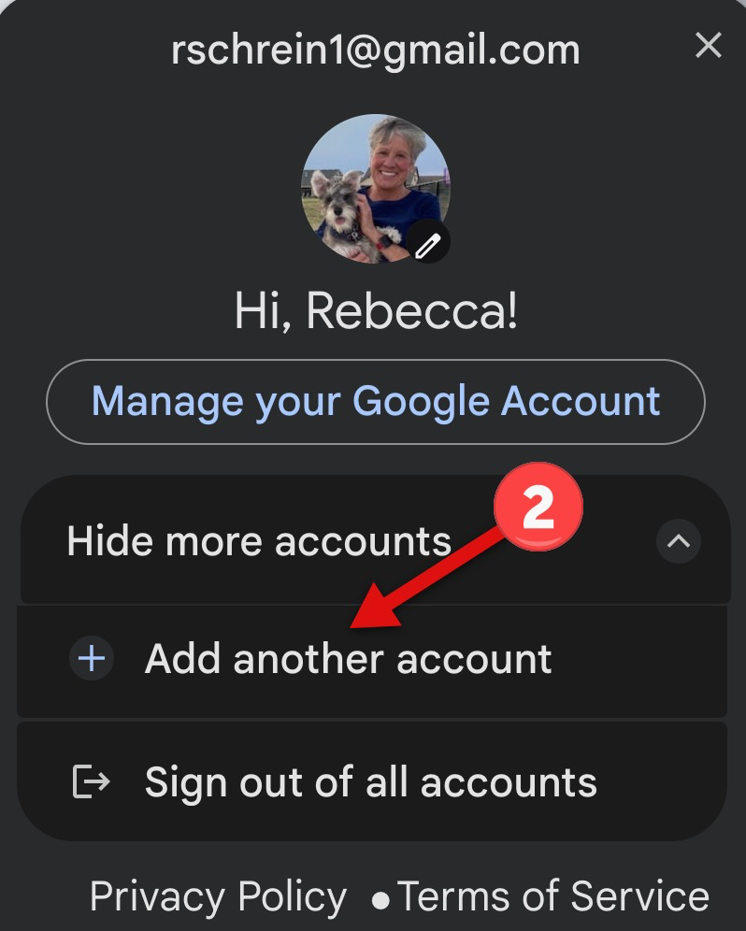

  - Enter the CAC’s Fairway Villas Email (cac.fairwayvillas@gmail.com)
  - Click the “Next” button
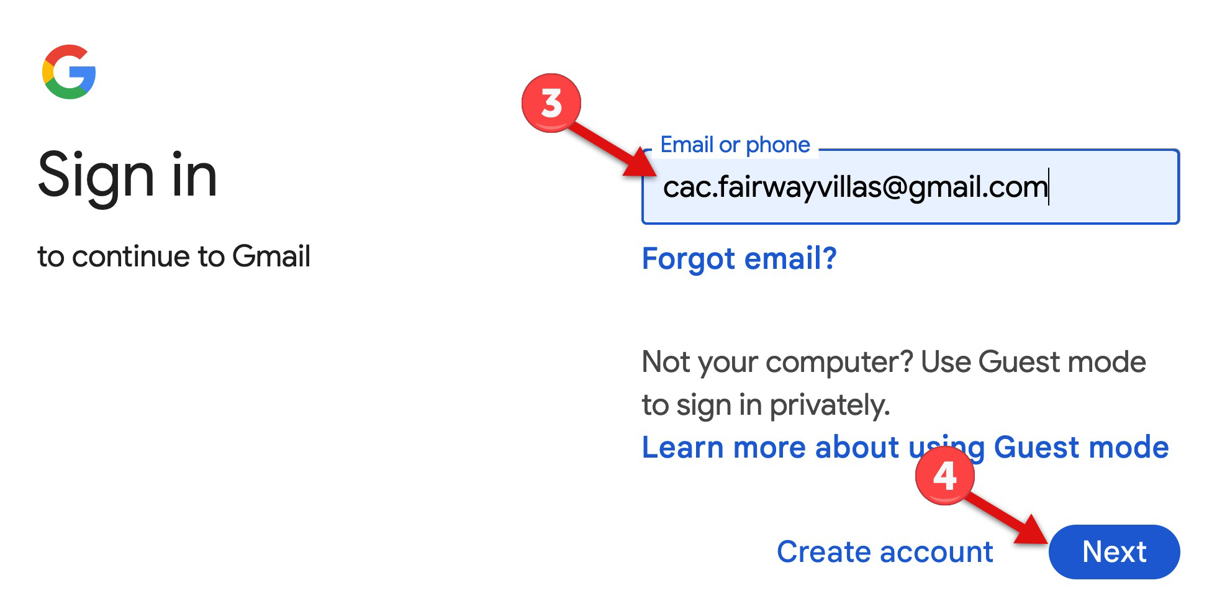

  - Click on “Try another way”
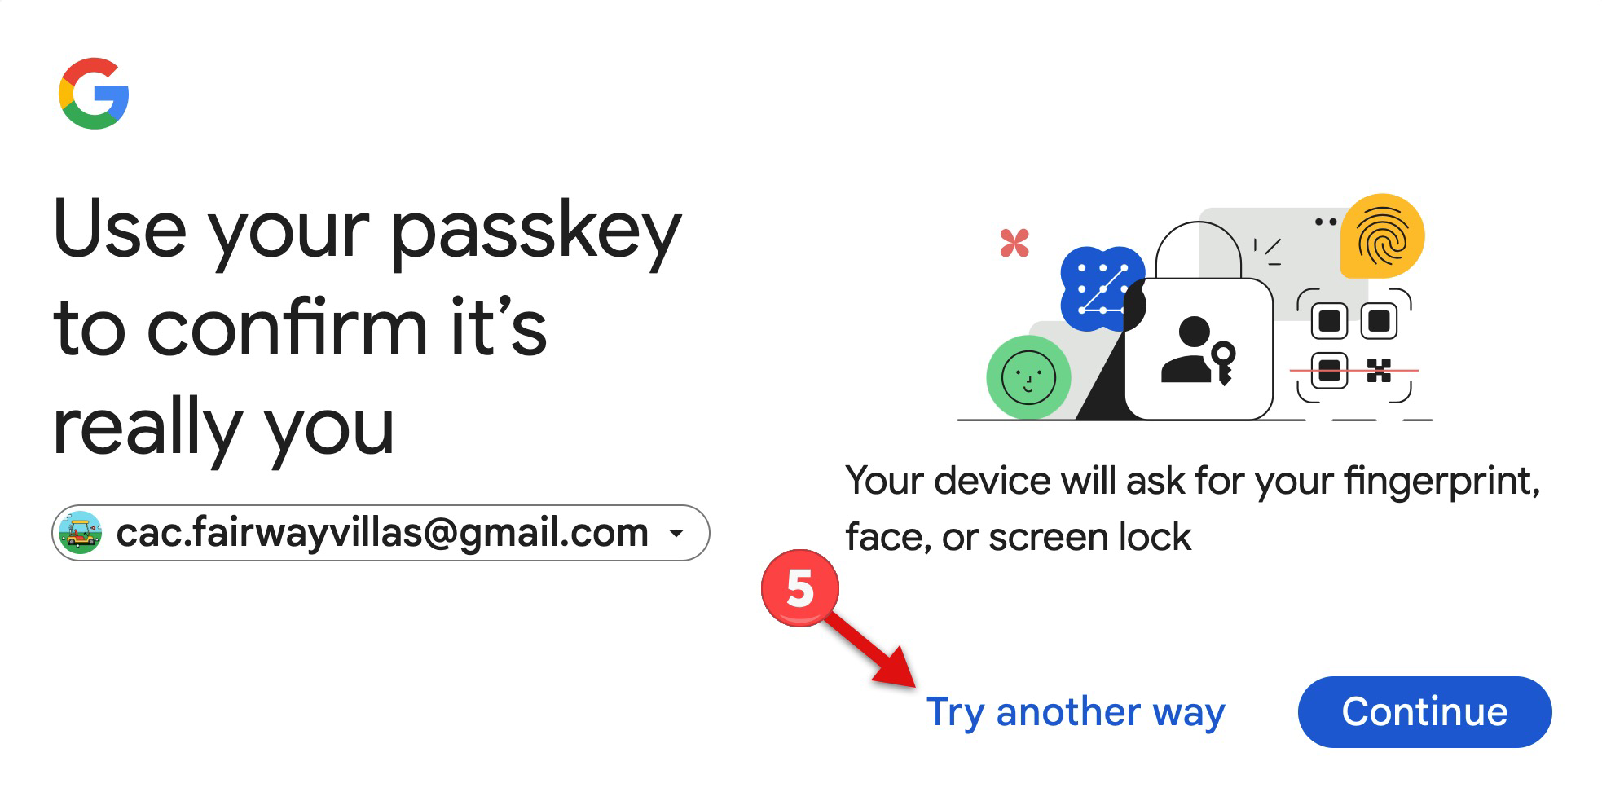
  - Click on “Use a phone, tablet, or security key”
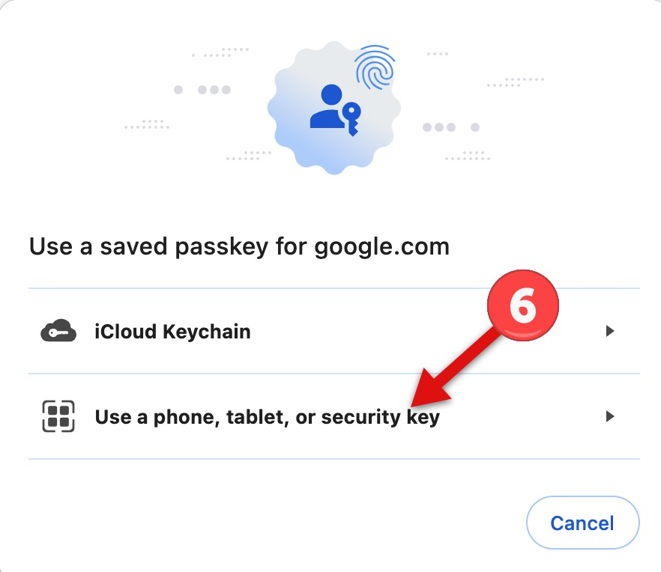

  - Click on “Enter your password”
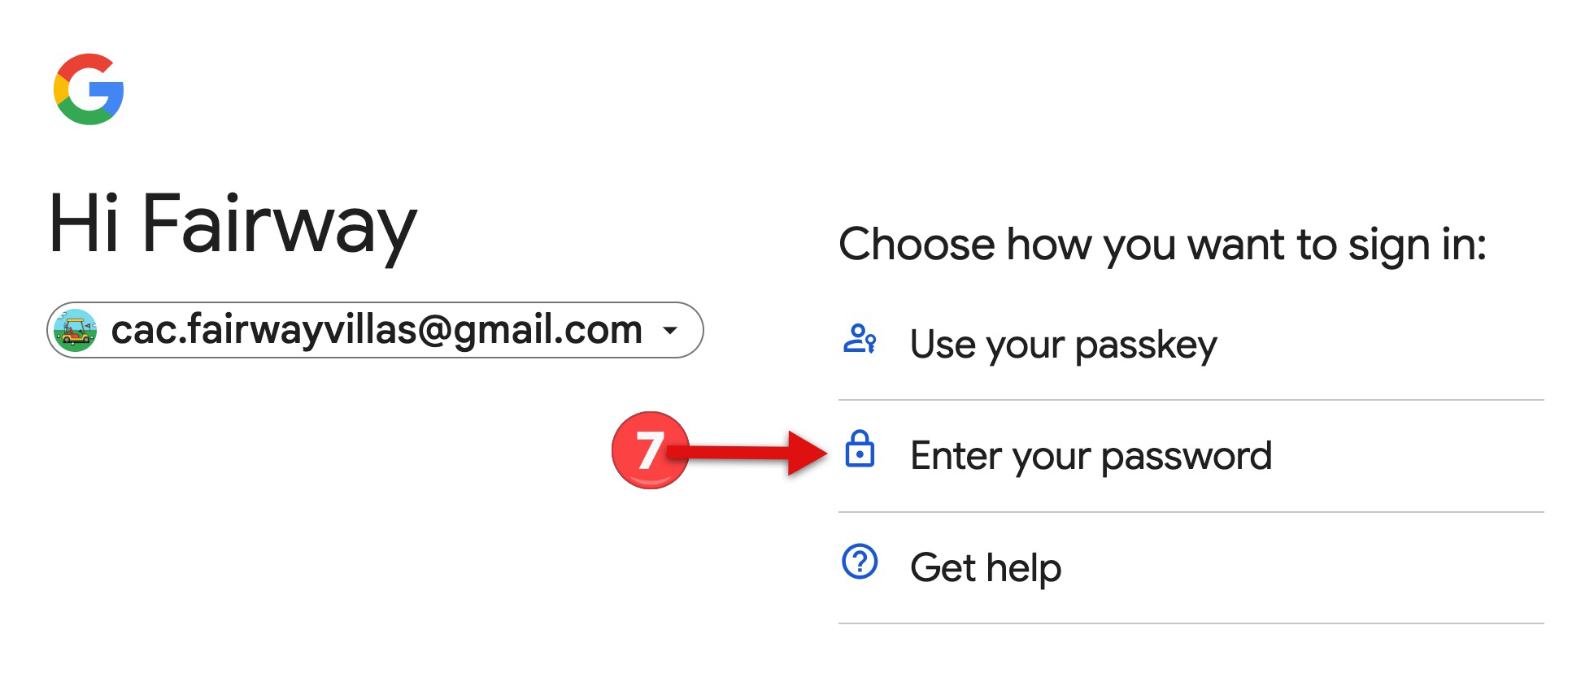

  - Enter your password
  - Click on the “Next button”
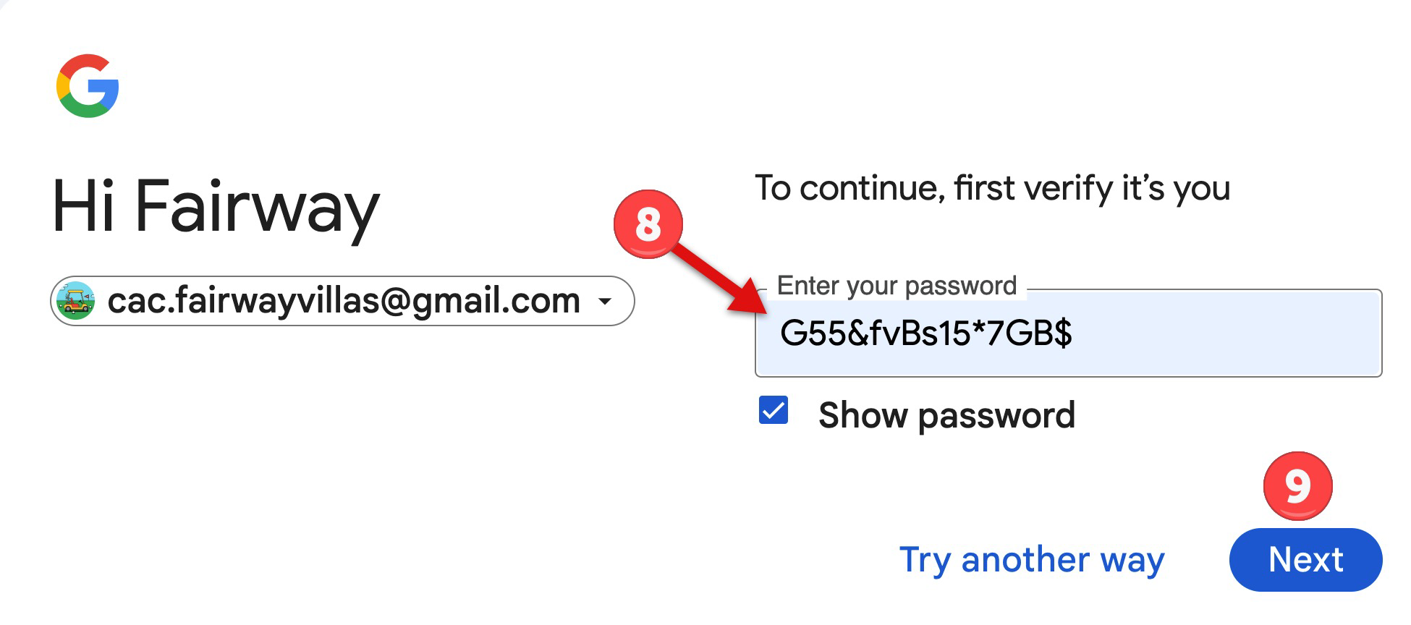

  - You can now see by the icon in the upper right hand corner you are now in the CAC Fairway Villas Email account.
    - Critical emails or those you do not know how to respond to; email all CAC members for assistance.
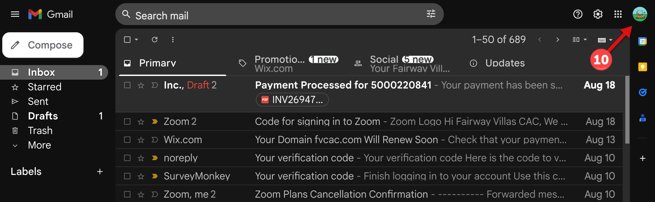
Once the account is setup you only need to do the following:
- Click on the icon in the upper right-hand corner
- Select the CAC Fairway Villas Email account
