YouTube INSTRUCTIONS

- Logging Into YouTube
Log into Zoom: https://www.youtube.com/
Click the Sign In button, upper right.
User Name: cac.fairwayvillas@gmail.com
Password: G55&fvBs15*7GB$

- Click the ‘3 Bars’ drop down to the left of the YouTube logo.
- Click on ‘Your Videos’.
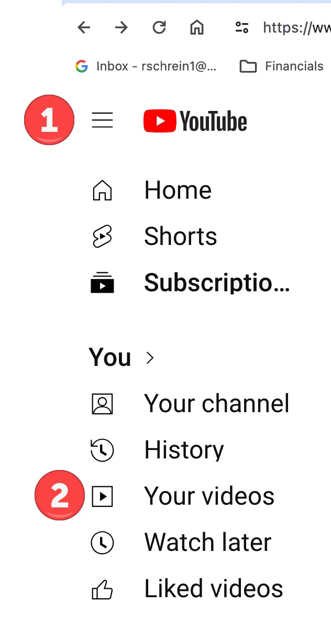

- You will see all the previously posted FV Zoom video recordings.
- Next click on ‘Dashboard’ in the left column.
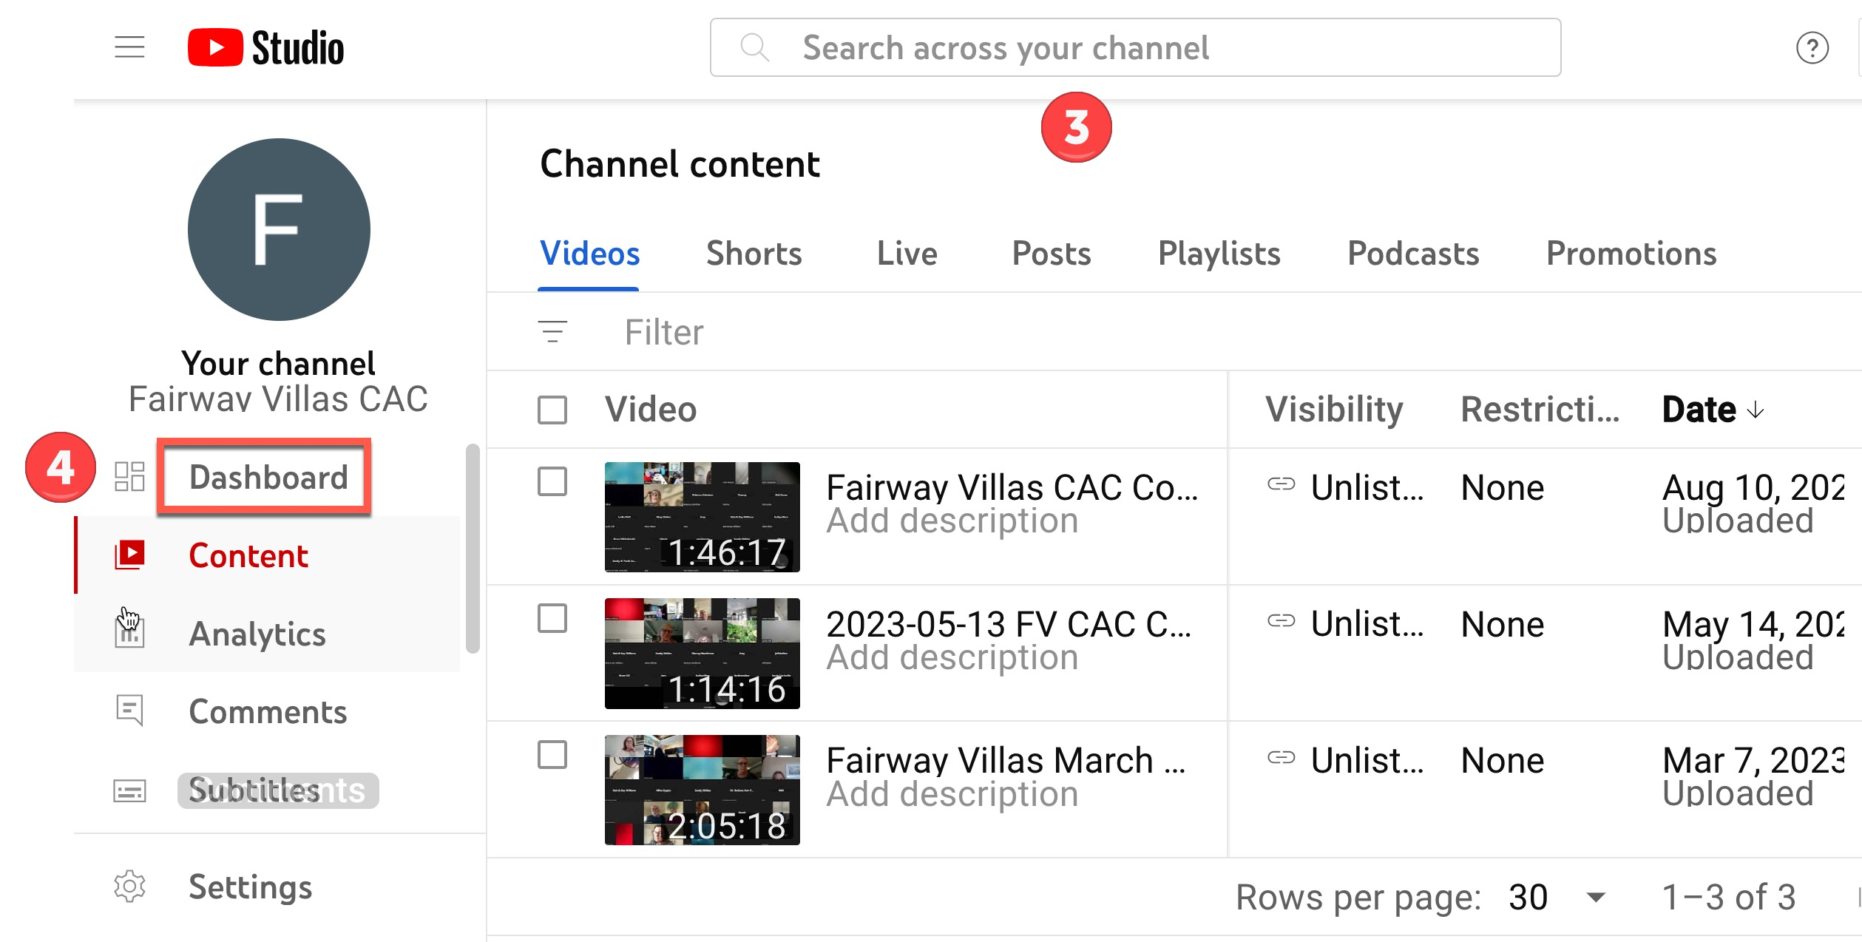
- Click on ‘Upload Video’.
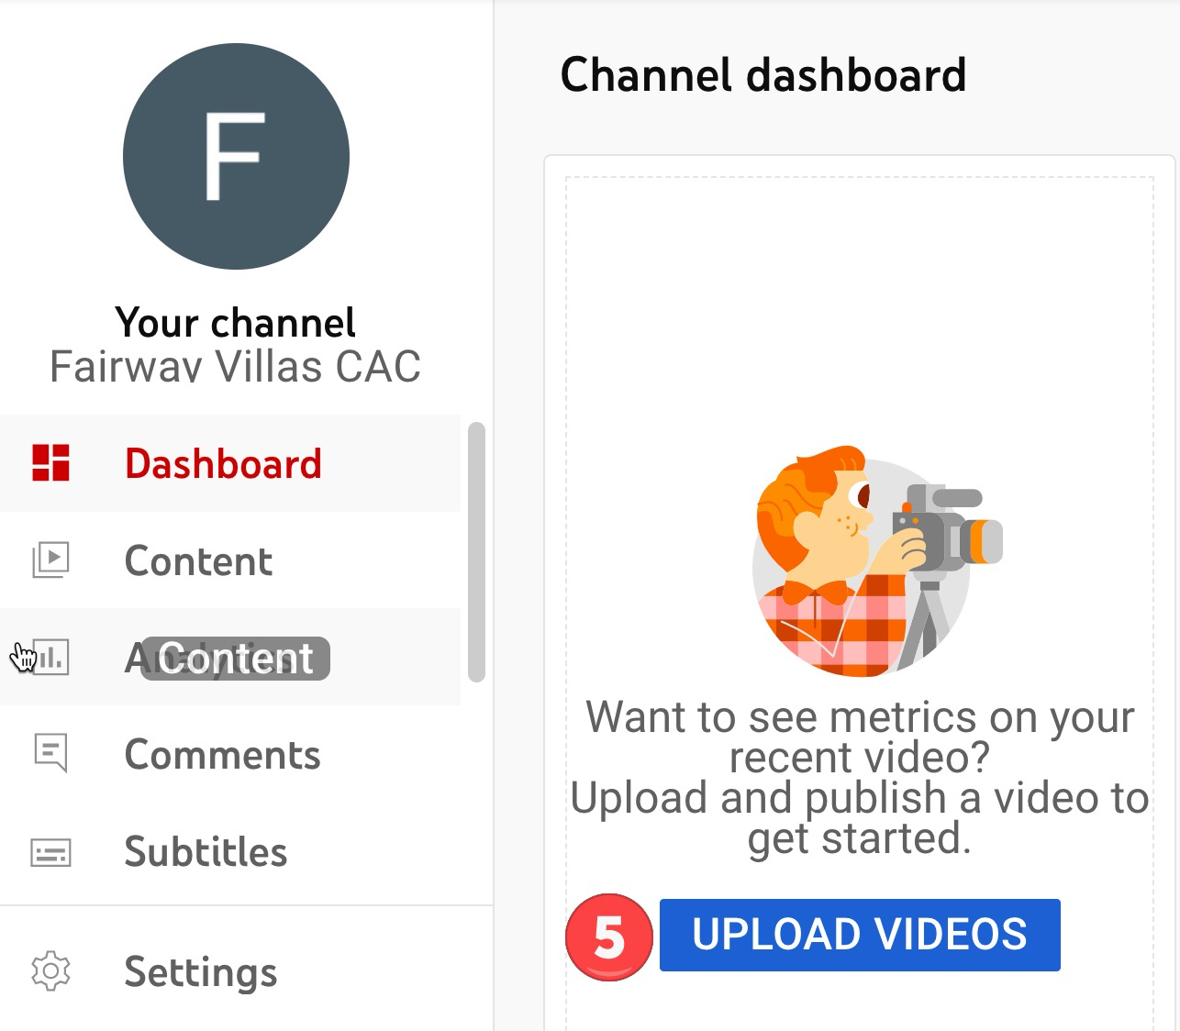

- Click ‘Select’ to upload video.
Note: You can also drag the video to the  in the middle of the screen, to upload.
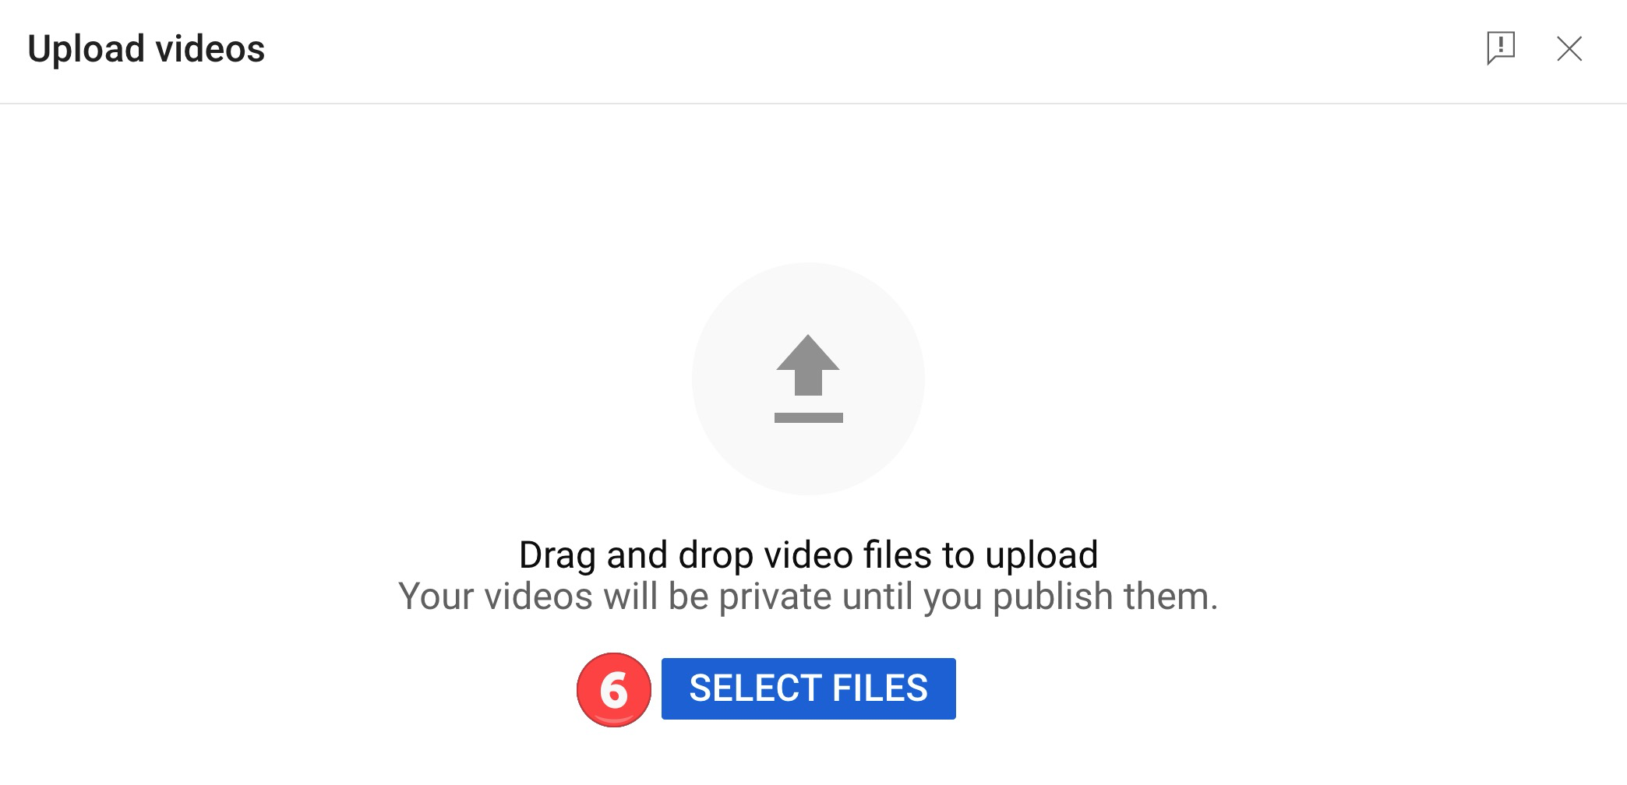

- Find the Zoom recording that was saved to your computer, select and click the ‘Open’ button.
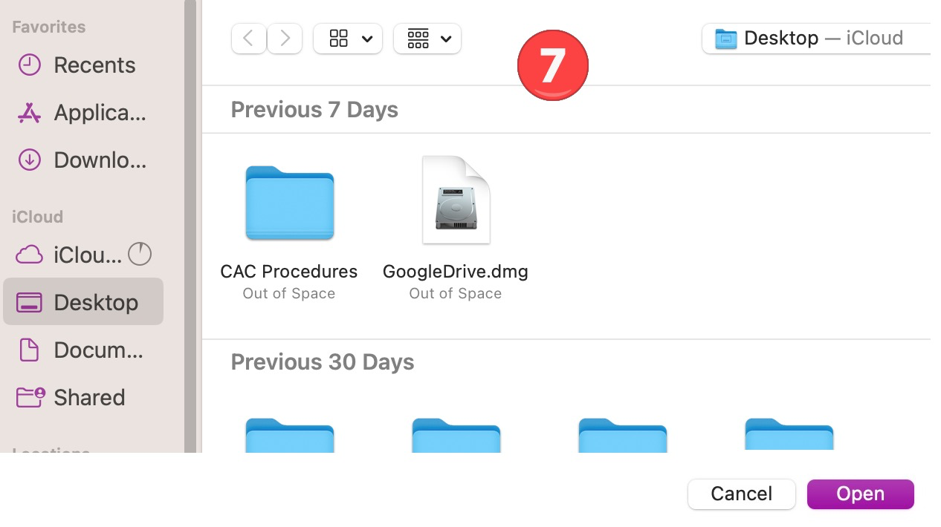
- Once added, open the Video.
- Copy the Link and send to CAC Website Admin (Becky).
