CAC Website (using WIX)

Link:
https://users.wix.com/signin/login?forceRender=true

- Enter Email: cac.fairwayvillas@gmail.com
- Enter Password: Brondos2020
- Click on Log In
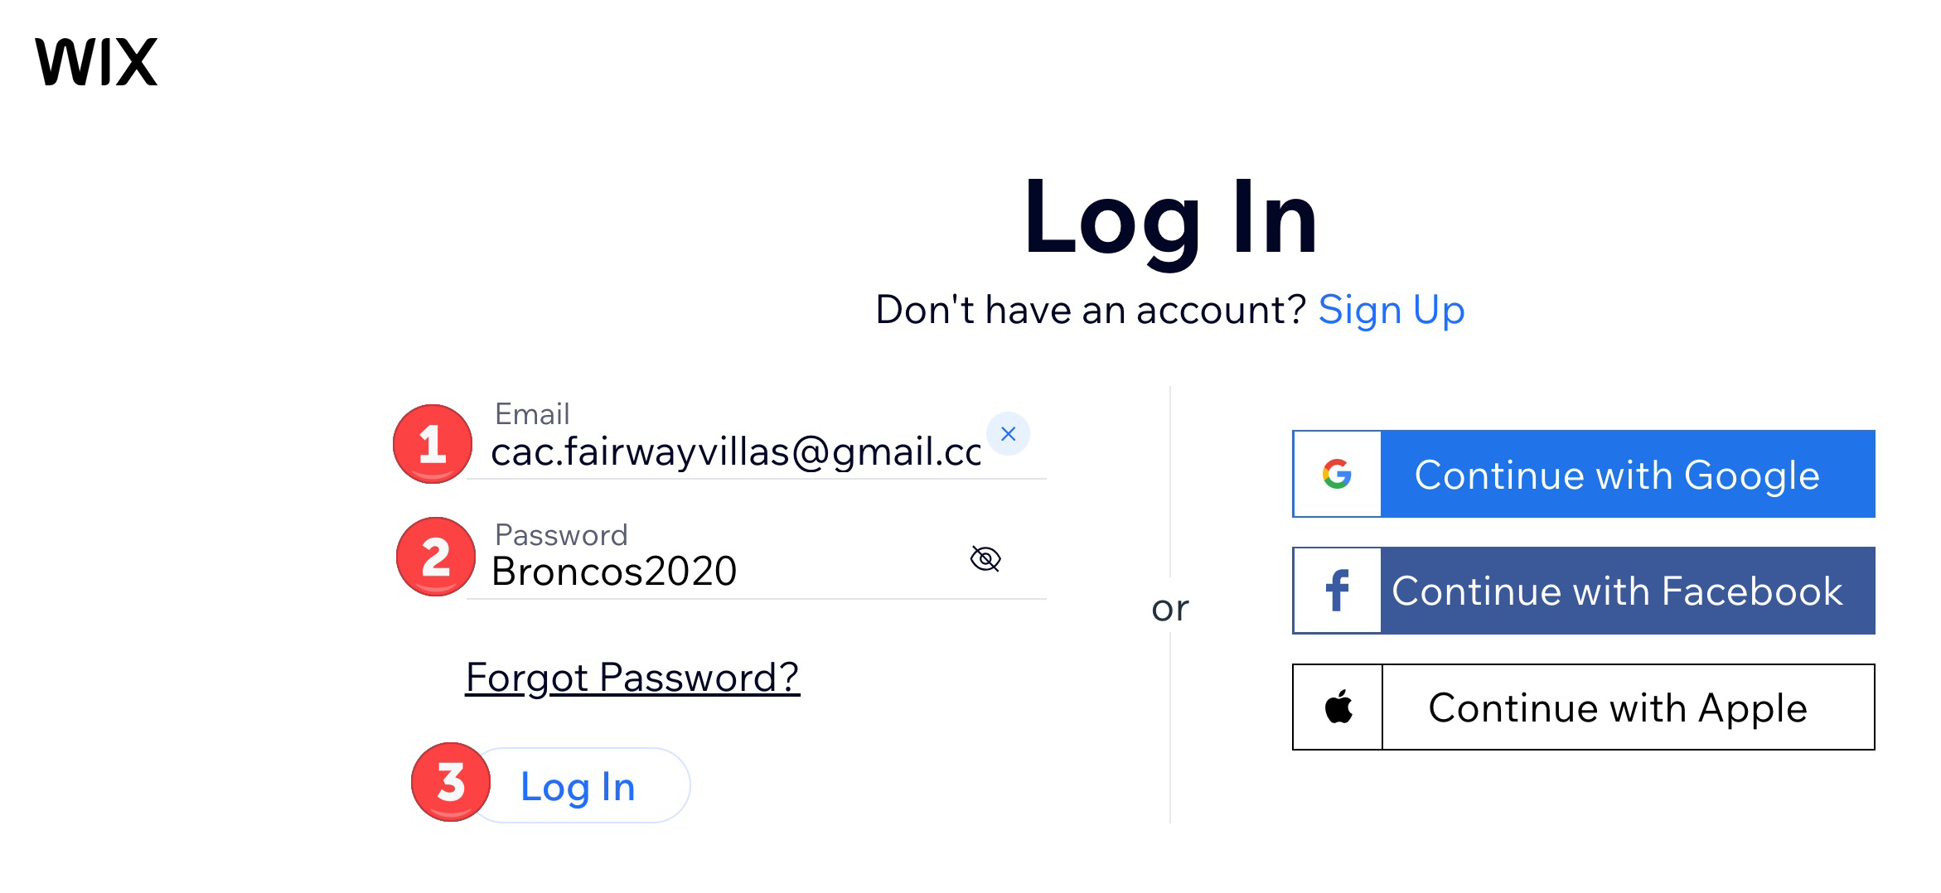

- A text will be sent to your phone with a 6 digit code, Enter the code
- Click the Verify button
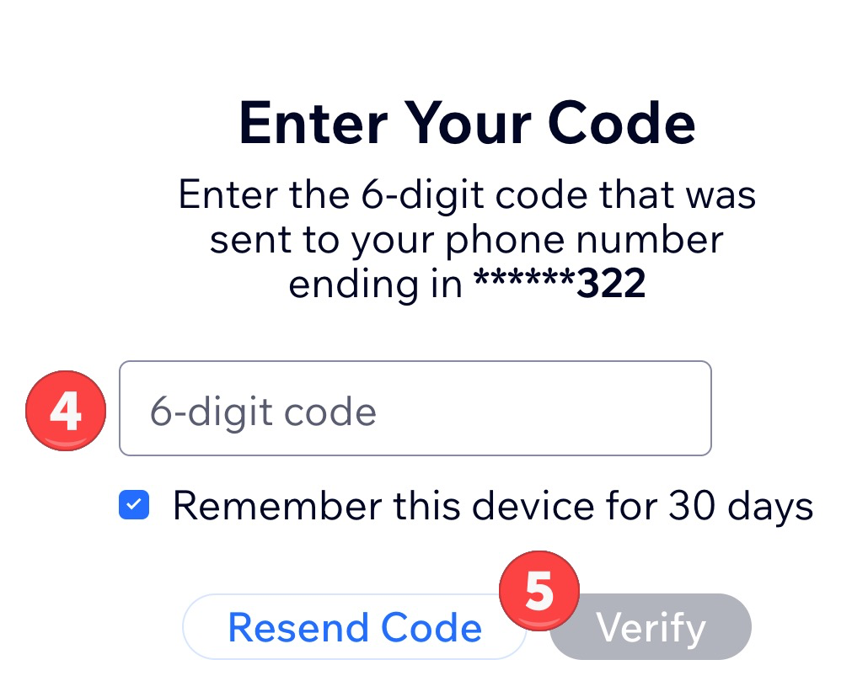

- Put cursor over Fairway Villas logo and click on Edit when it appears.
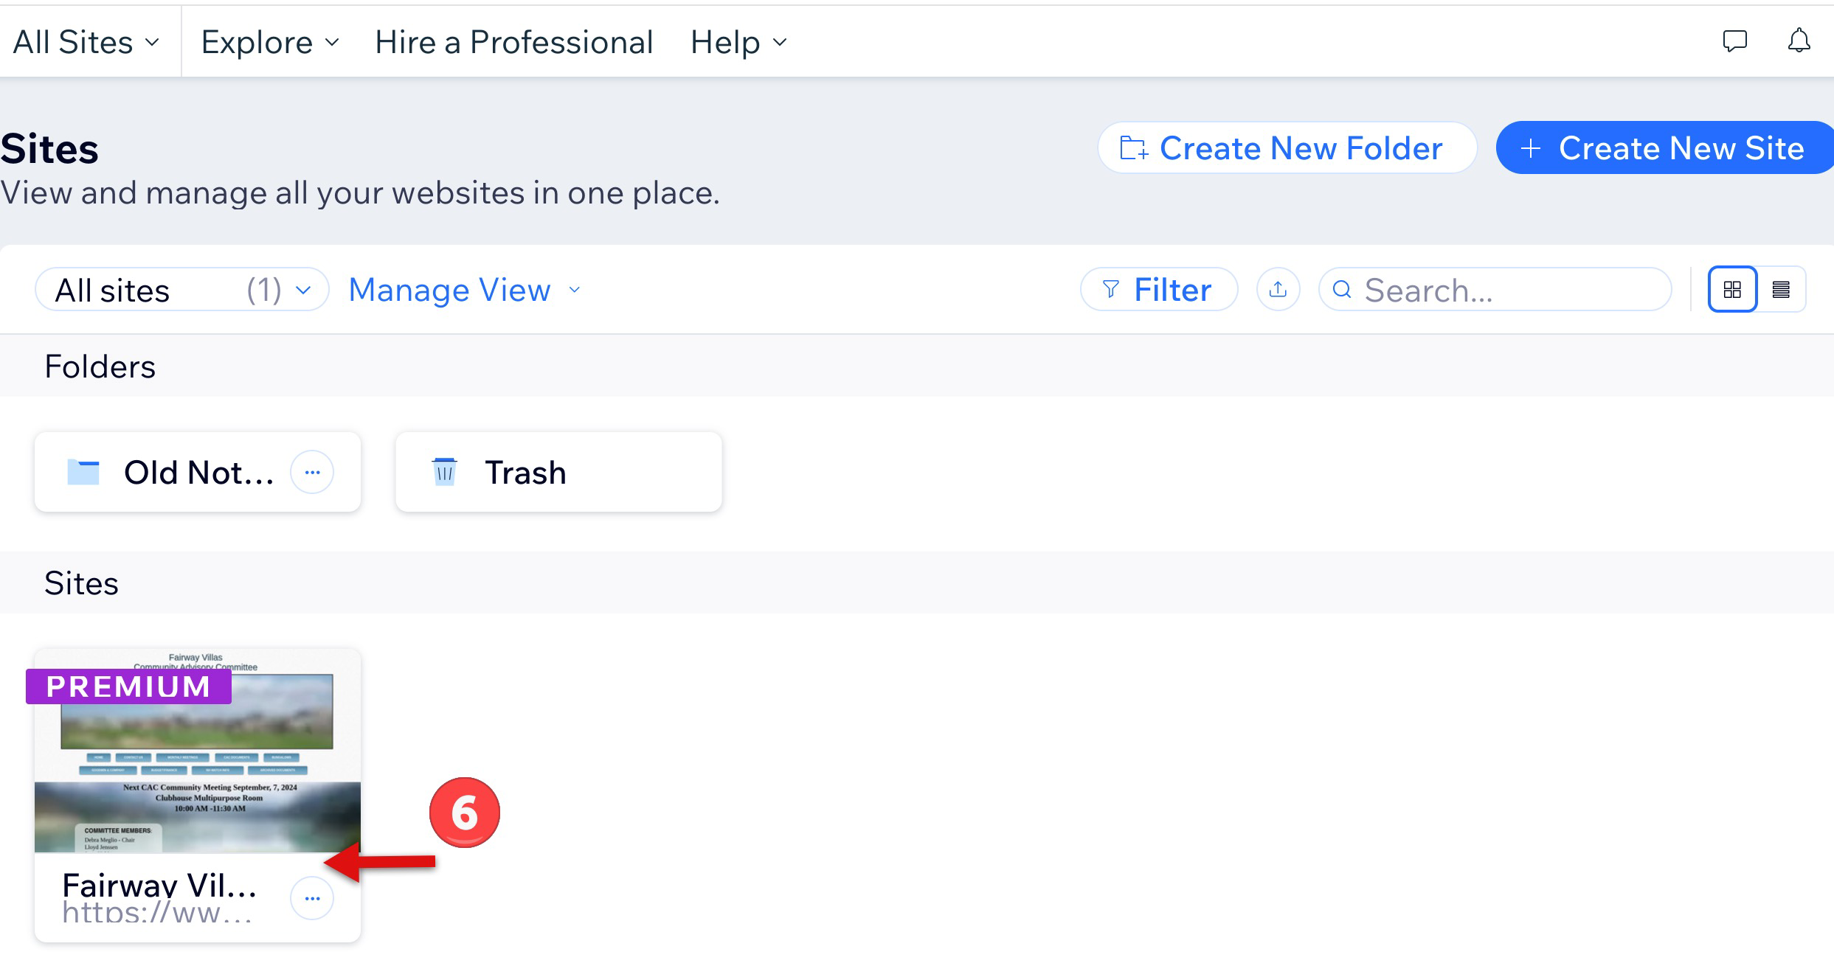
To Be Continued

